WEB PROGRAMMING LANGUAGE THEORY
CCP
INSTRUCTOR: SIR FARAZ ABDUL BASIT

MUHAMMAD BILAL
IU04-0122-0729
Screenshots:
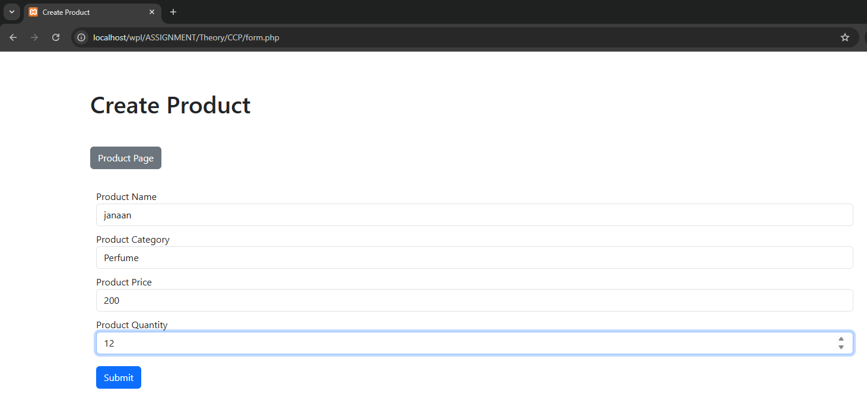
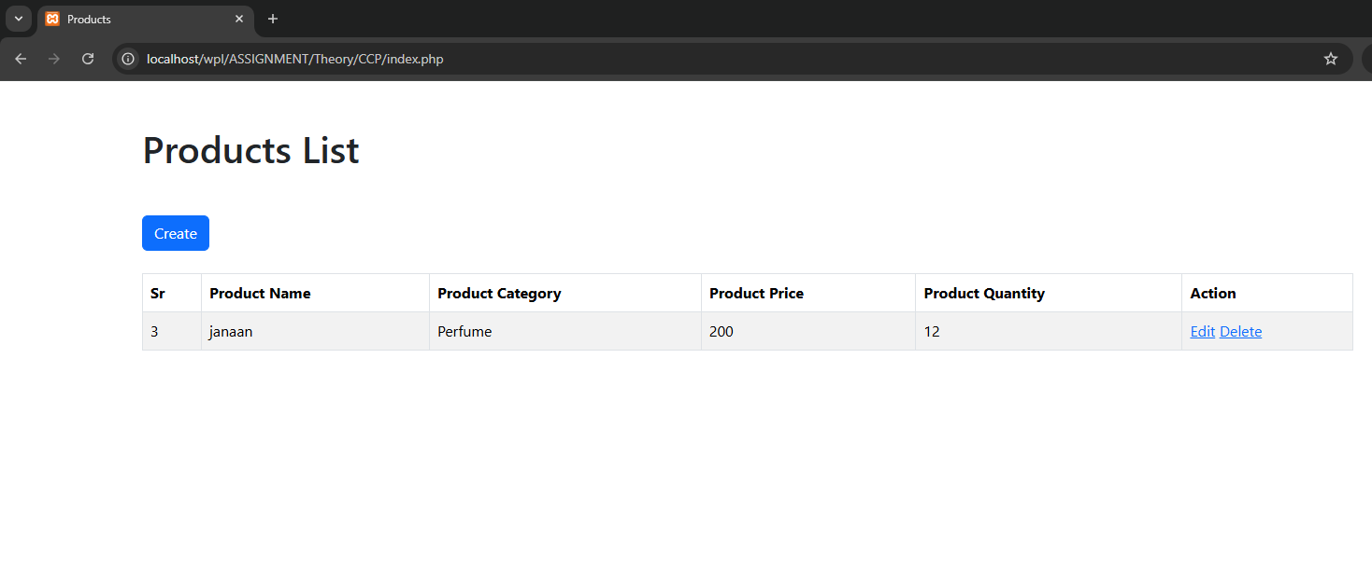

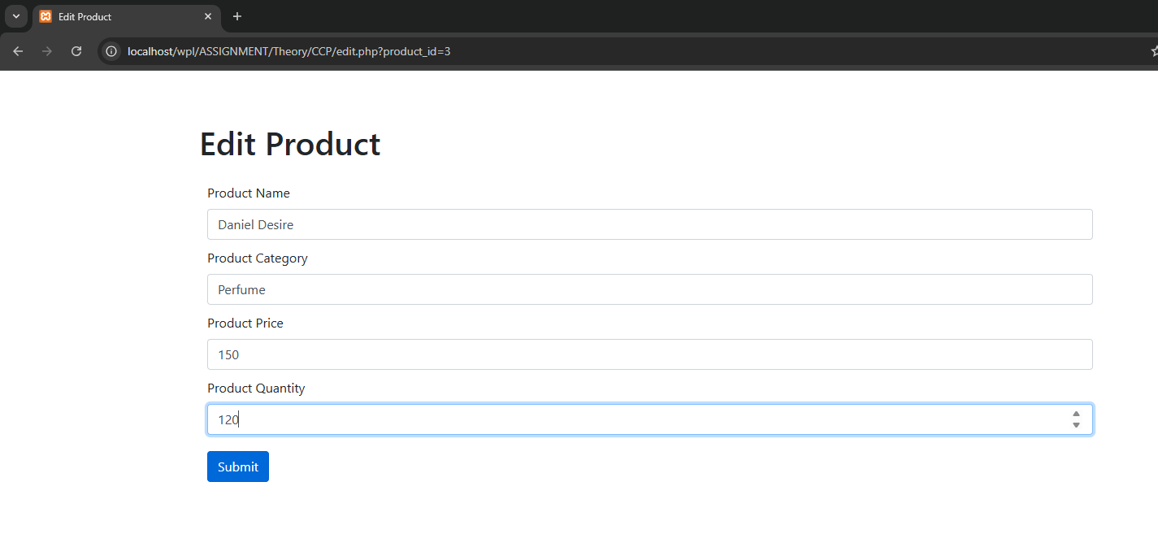
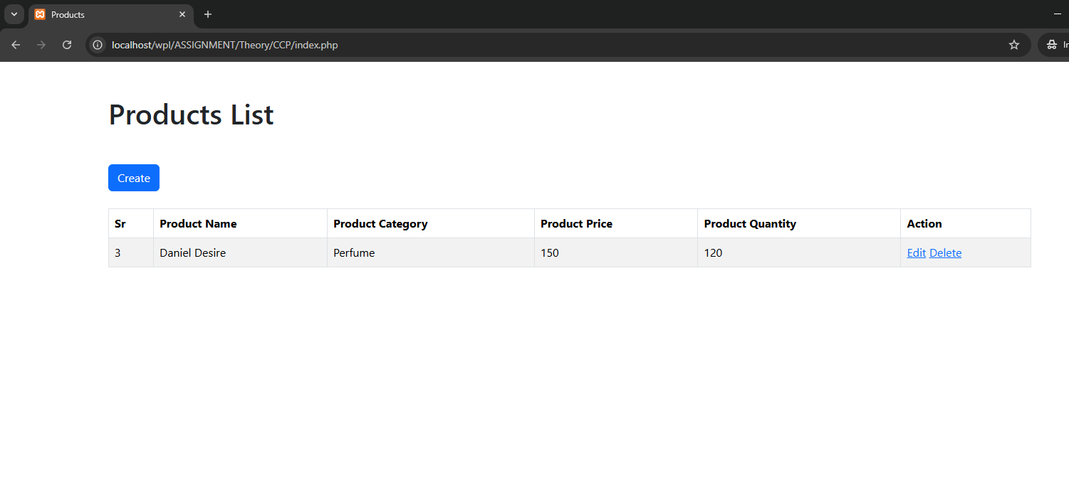

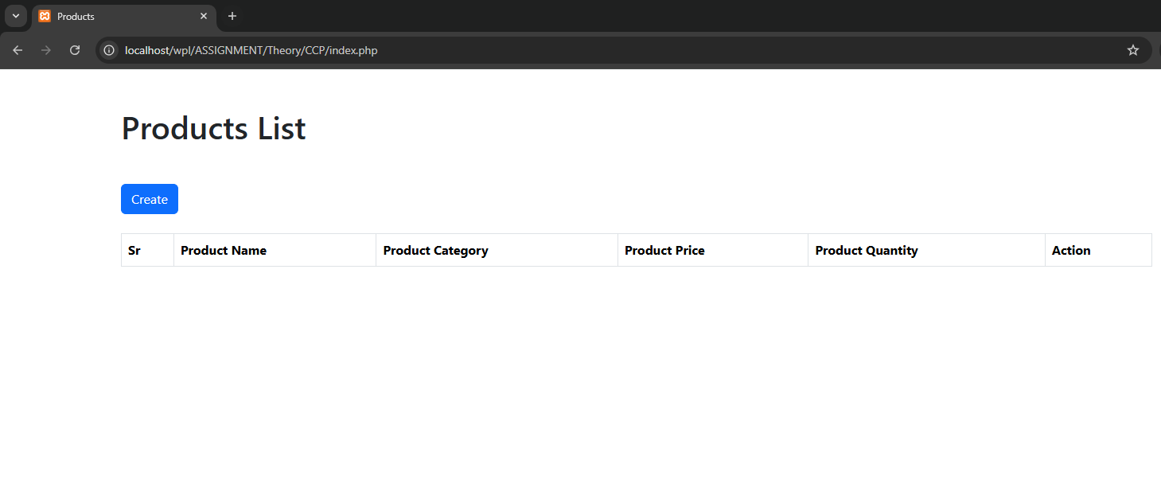

CODE:
Index.php:
<?php
$conn = mysqli_connect('localhost', 'root', '', 'e_commerce', '3307');

// Use prepared statement
$stmt = mysqli_prepare($conn, "SELECT * FROM products");
mysqli_stmt_execute($stmt);
$result = mysqli_stmt_get_result($stmt);
$data = mysqli_fetch_all($result, MYSQLI_ASSOC);
mysqli_stmt_close($stmt);
mysqli_close($conn);

?>
<!DOCTYPE html>
<html lang="en">

<head>
<meta charset="UTF-8">
<meta http-equiv="X-UA-Compatible" content="IE=edge">
<meta name="viewport" content="width=device-width, initial-scale=1.0">
<title>Products</title>
<script src="../../bootstrap/js/bootstrap.min.js"></script>
<link href="https://cdn.jsdelivr.net/npm/bootstrap@5.3.8/dist/css/bootstrap.min.css" rel="stylesheet"
integrity="sha384-sRIl4kxILFvY47J16cr9ZwB07vP4J8+LH7qKQnuqkuIAvNWLzeN8tE5YBujZqJLB" crossorigin="anonymous">

</head>

<body class="container mt-5">
<h1 class="my-4">Products List</h1>
<a href="form.php" class="btn btn-primary my-4">Create</a>

<table class="table table-bordered table-hover table-striped">
<thead>
<th>Sr</th>
<th>Product Name</th>
<th>Product Category</th>
<th>Product Price</th>
<th>Product Quantity</th>
<th>Action</th>
</thead>
<tbody>
<?php
for ($i = 0; $i < count($data); $i++) {
?>
<tr>
<td><?php echo $data[$i]['id'] ?></td>
<td><?php echo $data[$i]['product_name'] ?></td>
<td><?php echo $data[$i]['product_category'] ?></td>
<td><?php echo $data[$i]['product_price'] ?></td>
<td><?php echo $data[$i]['product_quantity'] ?></td>
<td>
<a href="edit.php?product_id=<?php echo $data[$i]['id'] ?>">Edit</a>
<a href="delete.php?product_id=<?php echo $data[$i]['id'] ?>">Delete</a>
</td>
</tr>
<?php
}
?>
</tbody>
</table>
</body>

</html>

Form.php:
<!DOCTYPE html>
<html lang="en">

<head>
<meta charset="UTF-8">
<meta http-equiv="X-UA-Compatible" content="IE=edge">
<meta name="viewport" content="width=device-width, initial-scale=1.0">
<title>Create Product</title>
<link href="https://cdn.jsdelivr.net/npm/bootstrap@5.3.8/dist/css/bootstrap.min.css" rel="stylesheet" integrity="sha384-sRIl4kxILFvY47J16cr9ZwB07vP4J8+LH7qKQnuqkuIAvNWLzeN8tE5YBujZqJLB" crossorigin="anonymous">
<script src="https://code.jquery.com/jquery-3.7.1.min.js"></script>

</head>

<body>
<div class="container mt-5 ">
<h1 class="py-3">Create Product</h1>
<a href="index.php" class="btn bg-secondary text-white my-4">Product Page</a>

<form>
<div class="form-group" style="margin: 10px;">
<label for="">Product Name</label>
<input type="text" class="form-control" name="product_name" id="product_name" placeholder="Enter product name">
</div>
<div class="form-group" style="margin: 10px;">
<label>Product Category</label>
<input type="text" class="form-control" name="product_category" id="product_category" placeholder="Enter product category">
</div>
<div class="form-group" style="margin: 10px;">
<label>Product Price</label>
<input type="number" class="form-control" name="product_price" id="product_price" placeholder="Enter product price">
</div>
<div class="form-group" style="margin: 10px;">
<label>Product Quantity</label>
<input type="number" class="form-control" name="product_quantity" id="product_quantity" placeholder="Enter product quantity">
</div>

<input type="button" class="btn btn-primary" id="submitbutton" style="margin: 10px;" value="Submit">
</form>
</div>

<script>
// jQuery with Regex Validation
$(document).ready(function() {
$('#submitbutton').click(function(){
// Get values
var productName = $('#product_name').val().trim();
var productCategory = $('#product_category').val().trim();
var productPrice = $('#product_price').val();
var productQuantity = $('#product_quantity').val();

// Regex patterns
var nameRegex = /^[a-zA-Z0-9\s\-_]{3,100}$/;
var categoryRegex = /^[a-zA-Z0-9\s\-_]{3,50}$/;
var priceRegex = /^[0-9]+(\.[0-9]{1,2})?$/;
var quantityRegex = /^[0-9]+$/;

// Validate Product Name
if (productName === '') {
alert('Product name is required!');
return false;
}
if (!nameRegex.test(productName)) {
alert('Product name must be 3-100 characters and contain only letters, numbers, spaces, hyphens, or underscores!');
return false;
}

// Validate Product Category
if (productCategory === '') {
alert('Product category is required!');
return false;
}
if (!categoryRegex.test(productCategory)) {
alert('Product category must be 3-50 characters and contain only letters, numbers, spaces, hyphens, or underscores!');
return false;
}

// Validate Product Price
if (productPrice === '') {
alert('Product price is required!');
return false;
}
if (!priceRegex.test(productPrice) || parseFloat(productPrice) <= 0) {
alert('Product price must be a valid positive number!');
return false;
}

// Validate Product Quantity
if (productQuantity === '') {
alert('Product quantity is required!');
return false;
}
if (!quantityRegex.test(productQuantity) || parseInt(productQuantity) <= 0) {
alert('Product quantity must be a valid positive integer!');
return false;
}

// If all validations pass, submit data
let data = {
'product_name': productName,
'product_category': productCategory,
'product_price': productPrice,
'product_quantity': productQuantity
}

$.ajax({
type: 'POST',
url: 'forrmSubmit.php',
data: data,
success: function(response){
console.log(response);
var result = JSON.parse(response);
alert(result.msg);
if(result.code === '201') {
// Clear form on success
$('#product_name').val('');
$('#product_category').val('');
$('#product_price').val('');
$('#product_quantity').val('');
}
},
error: function() {
alert('Error submitting form!');
}
});
});
});
</script>
</body>

</html>
FormSubmit.php
<?php
$conn = mysqli_connect('localhost', 'root', '', 'e_commerce', '3307');

// Get input values
$product_name = isset($_POST['product_name']) ? trim($_POST['product_name']) : '';
$product_category = isset($_POST['product_category']) ? trim($_POST['product_category']) : '';
$product_price = isset($_POST['product_price']) ? trim($_POST['product_price']) : '';
$product_quantity = isset($_POST['product_quantity']) ? trim($_POST['product_quantity']) : '';

// Regex validation in PHP
$nameRegex = '/^[a-zA-Z0-9\s\-_]{3,100}$/';
$categoryRegex = '/^[a-zA-Z0-9\s\-_]{3,50}$/';
$priceRegex = '/^[0-9]+(\.[0-9]{1,2})?$/';
$quantityRegex = '/^[0-9]+$/';

// Validate inputs
if (empty($product_name) || !preg_match($nameRegex, $product_name)) {
$response['msg'] = 'Invalid product name!';
$response['code'] = '400';
echo json_encode($response);
exit();
}

if (empty($product_category) || !preg_match($categoryRegex, $product_category)) {
$response['msg'] = 'Invalid product category!';
$response['code'] = '400';
echo json_encode($response);
exit();
}

if (empty($product_price) || !preg_match($priceRegex, $product_price) || $product_price <= 0) {
$response['msg'] = 'Invalid product price!';
$response['code'] = '400';
echo json_encode($response);
exit();
}

if (empty($product_quantity) || !preg_match($quantityRegex, $product_quantity) || $product_quantity <= 0) {
$response['msg'] = 'Invalid product quantity!';
$response['code'] = '400';
echo json_encode($response);
exit();
}

// Use prepared statement to prevent SQL injection
$stmt = mysqli_prepare($conn, "INSERT INTO products(product_name, product_category, product_price, product_quantity) VALUES (?, ?, ?, ?)");
mysqli_stmt_bind_param($stmt, "ssdi", $product_name, $product_category, $product_price, $product_quantity);

if(mysqli_stmt_execute($stmt)){
$response['msg'] = 'Data Inserted Successfully';
$response['code'] = '201';
echo json_encode($response);
}
else
{
$response['msg'] = 'Something went wrong';
$response['code'] = '500';
echo json_encode($response);
}

mysqli_stmt_close($stmt);
mysqli_close($conn);

edit.php:
<?php
// Validate product_id
$id = isset($_GET['product_id']) ? intval($_GET['product_id']) : 0;

if ($id <= 0) {
die('Invalid product ID!');
}

$conn = mysqli_connect('localhost', 'root', '', 'e_commerce', '3307');

// Use prepared statement to prevent SQL injection
$stmt = mysqli_prepare($conn, "SELECT * FROM products WHERE id = ?");
mysqli_stmt_bind_param($stmt, "i", $id);
mysqli_stmt_execute($stmt);
$result = mysqli_stmt_get_result($stmt);
$data = mysqli_fetch_all($result, MYSQLI_ASSOC);

mysqli_stmt_close($stmt);

if (empty($data)) {
die('Product not found!');
}

?>
<!DOCTYPE html>
<html lang="en">

<head>
<meta charset="UTF-8">
<meta http-equiv="X-UA-Compatible" content="IE=edge">
<meta name="viewport" content="width=device-width, initial-scale=1.0">
<title>Edit Product</title>
<script src="../../bootstrap/js/bootstrap.min.js"></script>
<link rel="stylesheet" href="../../bootstrap/css/bootstrap.min.css">
</head>

<body>
<div class="container mt-5">
<h1 class="py-3">Edit Product</h1>
<form method="post" action="editForrmSubmit.php" onsubmit="return validateEditForm()">
<div class="form-group" style="margin: 10px;">
<input value="<?php echo $data[0]['id']?>" type="hidden" class="form-control" name="product_id">
</div>
<div class="form-group" style="margin: 10px;">
<label for="">Product Name</label>
<input value="<?php echo $data[0]['product_name']?>" type="text" class="form-control" name="product_name" id="product_name" placeholder="Enter product name">
</div>
<div class="form-group" style="margin: 10px;">
<label>Product Category</label>
<input value="<?php echo $data[0]['product_category']?>" type="text" class="form-control" name="product_category" id="product_category" placeholder="Enter product category">
</div>
<div class="form-group" style="margin: 10px;">
<label>Product Price</label>
<input value="<?php echo $data[0]['product_price']?>" type="number" class="form-control" name="product_price" id="product_price" placeholder="Enter product price">
</div>
<div class="form-group" style="margin: 10px;">
<label>Product Quantity</label>
<input value="<?php echo $data[0]['product_quantity']?>" type="number" class="form-control" name="product_quantity" id="product_quantity" placeholder="Enter product quantity">
</div>

<input type="submit" class="btn btn-primary" style="margin: 10px;" value="Submit">
</form>
</div>

<script>
function SubmitForm() {
var firvalidateEditForm() {
// Get values
var productName = document.getElementById('product_name').value.trim();
var productCategory = document.getElementById('product_category').value.trim();
var productPrice = document.getElementById('product_price').value;
var productQuantity = document.getElementById('product_quantity').value;

// Regex patterns
var nameRegex = /^[a-zA-Z0-9\s\-_]{3,100}$/;
var categoryRegex = /^[a-zA-Z0-9\s\-_]{3,50}$/;
var priceRegex = /^[0-9]+(\.[0-9]{1,2})?$/;
var quantityRegex = /^[0-9]+$/;

// Validate Product Name
if (productName === '') {
alert('Product name is required!');
return false;
}
if (!nameRegex.test(productName)) {
alert('Product name must be 3-100 characters and contain only letters, numbers, spaces, hyphens, or underscores!');
return false;
}

// Validate Product Category
if (productCategory === '') {
alert('Product category is required!');
return false;
}
if (!categoryRegex.test(productCategory)) {
alert('Product category must be 3-50 characters and contain only letters, numbers, spaces, hyphens, or underscores!');
return false;
}

// Validate Product Price
if (productPrice === '') {
alert('Product price is required!');
return false;
}
if (!priceRegex.test(productPrice) || parseFloat(productPrice) <= 0) {
alert('Product price must be a valid positive number!');
return false;
}

// Validate Product Quantity
if (productQuantity === '') {
alert('Product quantity is required!');
return false;
}
if (!quantityRegex.test(productQuantity) || parseInt(productQuantity) <= 0) {
alert('Product quantity must be a valid positive integer!');
return false;
}

return true;
</script>
</body>

</html>

editSubmit.php:
<?php

$conn = mysqli_connect('localhost', 'root', '', 'e_commerce', '3307');

// Get and validate input values
$id = isset($_POST['product_id']) ? intval($_POST['product_id']) : 0;
$product_name = isset($_POST['product_name']) ? trim($_POST['product_name']) : '';
$product_category = isset($_POST['product_category']) ? trim($_POST['product_category']) : '';
$product_price = isset($_POST['product_price']) ? trim($_POST['product_price']) : '';
$product_quantity = isset($_POST['product_quantity']) ? trim($_POST['product_quantity']) : '';

// Regex validation in PHP
$nameRegex = '/^[a-zA-Z0-9\s\-_]{3,100}$/';
$categoryRegex = '/^[a-zA-Z0-9\s\-_]{3,50}$/';
$priceRegex = '/^[0-9]+(\.[0-9]{1,2})?$/';
$quantityRegex = '/^[0-9]+$/';

// Validate inputs
if ($id <= 0) {
die('Invalid product ID!');
}

if (empty($product_name) || !preg_match($nameRegex, $product_name)) {
die('Invalid product name!');
}

if (empty($product_category) || !preg_match($categoryRegex, $product_category)) {
die('Invalid product category!');
}

if (empty($product_price) || !preg_match($priceRegex, $product_price) || $product_price <= 0) {
die('Invalid product price!');
}

if (empty($product_quantity) || !preg_match($quantityRegex, $product_quantity) || $product_quantity <= 0) {
die('Invalid product quantity!');
}

// Use prepared statement to prevent SQL injection
$stmt = mysqli_prepare($conn, "UPDATE products SET product_name = ?, product_category = ?, product_price = ?, product_quantity = ? WHERE id = ?");
mysqli_stmt_bind_param($stmt, "ssdii", $product_name, $product_category, $product_price, $product_quantity, $id);
mysqli_stmt_execute($stmt);
mysqli_stmt_close($stmt);
mysqli_close($conn);

header('Location: index.php');
exit();

delete.php:
<?php
// Validate product_id
$id = isset($_GET['product_id']) ? intval($_GET['product_id']) : 0;

if ($id <= 0) {
die('Invalid product ID!');
}

$conn = mysqli_connect('localhost', 'root', '', 'e_commerce', '3307');

// Use prepared statement to prevent SQL injection
$stmt = mysqli_prepare($conn, "DELETE FROM products WHERE id = ?");
mysqli_stmt_bind_param($stmt, "i", $id);
mysqli_stmt_execute($stmt);
mysqli_stmt_close($stmt);
mysqli_close($conn);

header('Location: index.php');
exit();

